PH

PH Order Request

I read the warning, and I fully understand all the risks. I make this decision to participage the centunion, being of sound mind and memory

Cancel

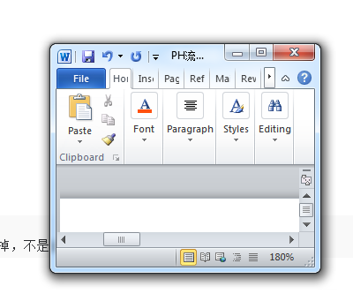 订单有外边框类似WORD，透明带点颜色。

Warning: At vero eos et accusamus et iusto odio dignissimos ducimus qui blanditiis praesentium voluptatum deleniti atque corrupti quos dolores et quas molestias excepturi sint occaecati cupiditate non provident, similique sunt in culpa qui officia deserunt mollitia animi, id est laborum et dolorum fuga. Et harum quidem

Next

PH Order Request

Currency System You choose to provide assistance on

Enter Deposit Amount to join in Centurion system

USD-United States Dollar

Minimum:100 USD Maxmun:10 000 USD

USD/BITCOIN

（现在的还有点bug，点击窗口以外的位置，窗口会自动消失,）

加一个可以滑动的金额条。

这里有个交互，根据等级不同，maxmum金额不同

1-9级上限1W

10-12级上限2W，13等级上限3W。

Cancel

Next

back

新的PH 限额还需要减去当前存在的deposit金额

PH Order Request

**PH order summary**

Currency System You choose to provide assistance on

**USD/BITCOIN**

And Deposit Amount to join in Centruion system

**10 000 USD: United States Dollor**

**ATTENTION: MAKE SURE ALL THE DETAILS ARE CORRECT**

**WARNING: PH Order Request cannot be cancelled after you submit**

Submit

Cancel

back

Submit 之后 有条信息显示 成功，过过几秒自动消失，没消失的时候也不影响其他操作或者点击。

与此同时出现 PH order 显示在dashbord

PH/GH 订单有两种颜色，比如完成前醒目，完成后，变为灰色等等。

Request to Provide Help

P12345678

Participant: Frank

Amount: 810 USD

Date: 04/16/2016

Status: Is in queue for dispatcher

Detail

**PH**

刷新或者间隔1分钟，匹配10%

Request to Provide Help

P12345678

Participant: Frank

Amount: 810 USD

Date: 04/16/2016

Balance： 710 USD

Status: Is in queue for dispatcher

Detail

**PH**

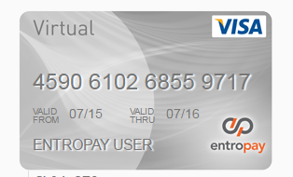 **外观可以弄得跟卡是的。然后加上logo或者水印**

GH 风格可以根据PH 来，也是三步。细节请和Violin商量

参考以下，细节跟VIOLIN 协商

**Operational Flow Chart for Users**

Page 2 ~ 3: Provide Help Flow Chart

Page 4: Get Help Flow Chart

Page 5 ~ 13: Images of Provide Help Process

Page 14 ~ 16: Images of Get Help Process

This sign: in the flow chart means that the 1st image corresponds to that step.

1

Provide Help Flow Chart:

Start

Back

Back

Back

Cancel

Cancel

Cancel

Cancel

Fail

No

Next

Next

Next

Next

Register

Yes

Select currency

Has registered ?

Log in

Click “Provide Help”

Warning

Confirm

Input amount

Success! Wait to be matched

End

1

6、4

5、4

4、4

3、4

2

After the ProvideHelp order has been matched,

15

14

11

12

13

9

10

Cancel

Cancel

Next

Back

Next

Consent but not now

or

Refuse

Complete

Fail

End

Success

Confirm

Upload screenshot

Whether to pay

Click “Details”

Make payment (Blockchain)

Start

Get Help Flow Chart:

LETTER OF HAPPINESS

23

22

21

20

19

18

17

16

Cancel

Cancel

Cancel

Next

Back

Next

Cancel

Back

Back

Back

Next

Add new account

Input account details

Yes

No

Attention

Fail

Select existing wallet

Input amount

Confirm

End

Success

Select bank account

Click “Get Help”

Has unfinished order?

Start

①